Supporting Document
Case Study: Installing Self check out systems in a chain of supermarkets

Stakeholder Register:
Name | Role | Department | Power | Interest | Influence | Expectations | Engagement Strategy | Contact | Notes
RACI Matrix:
Activity / Role | Business Sponsor | Ops Head | IT Head | Finance | Store Manager | Vendor | BA
Business Case Approval | A | C | I | C | I | I | R
Budget Approval | A | I | I | A | I | I | C
Vendor Selection | C | C | C | C | I | R | R
Solution Design | I | C | A | I | C | R | R
Requirements (BRD) | I | C | C | C | C | I | A/R
System Integration | I | I | A | I | I | R | C
Store Rollout Planning | I | A | I | I | R | C | C
Staff Training | I | A | I | I | R | C | C
UAT Sign-off | I | A | A | I | C | I | R
Go-Live Approval | A | C | C | C | I | I | I
Post-Implementation Review | A | R | C | C | C | I | R

Power Interest Matrix:
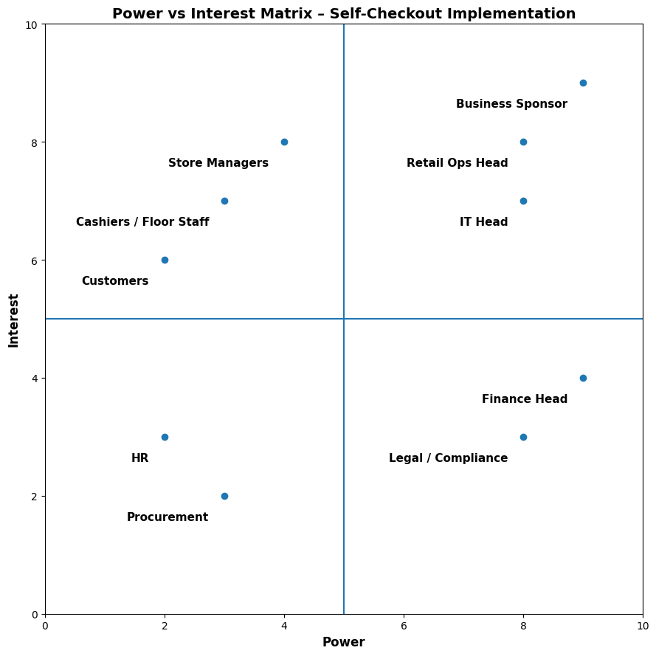

Stakeholder Communication Plan:
Stakeholder | Information Needed | Frequency | Channel | Owner
Business Sponsor | ROI, risks, pilot results | Weekly | Email + Review Call | BA
Retail Ops Head | Process readiness, KPIs | Weekly | Dashboard + Meeting | BA
IT Head | Integration status, incidents | Weekly | Stand-up / Email | IT Lead
Finance Team | Costs, savings tracking | Monthly | Report | Finance Analyst
Store Managers | SOPs, training schedules | Weekly | In-person / Mail | BA
Cashiers | Process changes, role clarity | Before go-live | Training sessions | Store Manager
Customers | How to use self-checkout | One-time (pilot) | Signage / Demo | Floor Staff
Vendor | Implementation status | Weekly | Call / Email | BA

Root Cause Analysis: 5 Why technique
Why?
Because customers wait too long at cashier counters.
Why?
Because the number of cashiers is insufficient during peak times.
Why?
Because adding more cashiers increases labour cost significantly.
Why?
Because checkout throughput depends entirely on human-operated counters.
Why?
Because there is no alternative self-service or automated checkout option.
RCA Fishbone diagram:
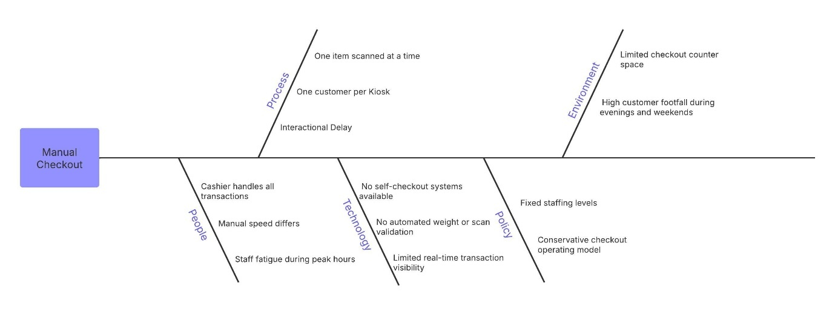
Gap Analysis:
Area | AS-IS State | TO-BE State | Gap Identified | Impact
Checkout Time | High wait times during peak hours | Reduced checkout time using self-checkout | Checkout speed limited by cashier availability | Customer dissatisfaction, lost sales
Queue Management | Long queues at staffed counters | Multiple parallel self-checkout kiosks | Insufficient checkout points | Cart abandonment
Staff Utilization | One cashier per counter | One staff member supervising multiple kiosks | Inefficient staff deployment | High labor cost
Scalability | Adding staff required for growth | Digital scaling via kiosks | Linear growth model | Operational inflexibility
Customer Control | Low (cashier-dependent) | High (self-service) | Limited customer autonomy | Lower satisfaction
Error Detection | Manual error handling | Automated weight & scan validation | Late error detection | Increased shrinkage risk
Reporting | Limited transaction insights | Detailed transaction & exception reports | Lack of visibility | Poor decision-making

Requirement Traceability Matrix:
Objective ID | Business Objective | BR ID | Business Requirement | FR ID | Functional Requirement | KPI / Success Metric
OBJ-01 | Reduce checkout wait time | BR-01 | Reduce average checkout time by ≥30% | FR-01 | Customers can scan items independently | Avg checkout time ↓ 30–40%
OBJ-01 | Reduce checkout wait time | BR-01 | Reduce average checkout time by ≥30% | FR-02 | System validates items using weight check | Queue length ↓ 35–50%
OBJ-01 | Reduce checkout wait time | BR-01 | Reduce average checkout time by ≥30% | FR-03 | Enable fast payment completion | Transactions/hour ↑ 25–40%
OBJ-02 | Optimize labor costs | BR-02 | Reduce cashier dependency during peak hours | FR-04 | One staff member supervises multiple kiosks | Labor cost ↓ 20–30%
OBJ-02 | Optimize labor costs | BR-02 | Reduce cashier dependency during peak hours | FR-05 | Staff override for exceptions | Staff productivity ↑ 25–35%
OBJ-03 | Improve customer experience | BR-03 | Enable faster checkout for small baskets | FR-06 | Support multiple payment modes | CSAT ≥ 85%
OBJ-03 | Improve customer experience | BR-03 | Enable faster checkout for small baskets | FR-07 | Generate digital / printed receipt | Adoption rate ≥ 50%
OBJ-04 | Maintain operational control | BR-04 | Preventing theft and scanning errors | FR-08 | Weight mismatch alert mechanism | Shrinkage ≤ baseline
OBJ-04 | Maintain operational control | BR-04 | Preventing theft and scanning errors | FR-09 | Transaction & exception reporting | Exception rate ≤ 5%
OBJ-05 | Ensure system reliability | BR-05 | Ensure high system availability | FR-10 | Monitor system uptime & health | Uptime ≥ 99.5%

Process Flow Diagram:
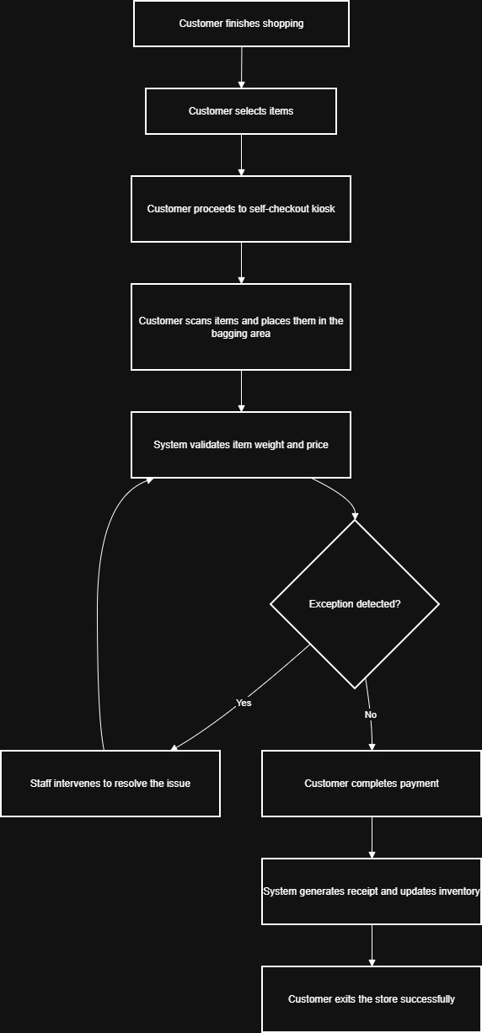
User Acceptance Testing:
UAT ID | Objective ID | BR ID | FR ID | UAT Scenario | Description | Expected Result | Acceptance Criteria
UAT-01 | OBJ-01 | BR-01 | FR-01 | Item scanning by customer | Customer scans items independently at self-checkout | Items scanned correctly and added to bill | 100% scanned items appear correctly
UAT-02 | OBJ-01 | BR-01 | FR-02 | Weight validation | System validates item weight in bagging area | Correct weight accepted, mismatch triggers alert | Weight mismatch alerts within 2 seconds
UAT-03 | OBJ-01 | BR-01 | FR-03 | Fast payment completion | Customer completes payment using card/UPI | Payment successful and checkout completed | Payment processed under 5 seconds
UAT-04 | OBJ-02 | BR-02 | FR-04 | Multi-kiosk supervision | One staff member monitors multiple kiosks | Staff can oversee and assist all kiosks simultaneously | No kiosk blocked due to lack of staff
UAT-05 | OBJ-02 | BR-02 | FR-05 | Staff override for exceptions | Staff resolves scanning/payment exception | Override applied and checkout resumes | Override completed under 30 seconds
UAT-06 | OBJ-03 | BR-03 | FR-06 | Multiple payment modes | System supports UPI, card, wallet payments | Customer can choose preferred payment mode | All payment modes function without failure
UAT-07 | OBJ-03 | BR-03 | FR-07 | Receipt generation | System generates digital/printed receipt | Receipt issued after successful payment | Receipt matches transaction details
UAT-08 | OBJ-04 | BR-04 | FR-08 | Theft prevention alert | Unscanned item placed in bagging area | System detects mismatches and alerts staff | Alert triggered in all mismatch cases
UAT-09 | OBJ-04 | BR-04 | FR-09 | Transaction & exception reporting | System records transaction and exception logs | Reports available for operations review | 100% transactions logged accurately
UAT-10 | OBJ-05 | BR-05 | FR-10 | System uptime monitoring | System operates without downtime during peak hours | System available as per SLA | Uptime ≥ 99.5%

Change Impact Assessment:
Stakeholder Group | Current State (AS-IS) | Future State (TO-BE) | Impact Level | Impact Type | Mitigation / Action
Cashiers | Manual billing for all customers | Exception handling + kiosk supervision | High | Role & workflow change | Training, role clarity, redeployment
Store Managers | Manage staffed counters | Manage hybrid checkout model | Medium | Process & reporting change | SOP updates, pilot involvement
Customers | Cashier-led checkout | Self-service option introduced | Medium | Behavioral change | In-store assistance, signage
Retail Ops Team | Manual staffing optimization | Digital throughput optimization | Low | Process improvement | Dashboard reporting
IT Team | Supports POS only | Supports POS + kiosks | Medium | Support & integration change | SLA, monitoring tools
Finance Team | Labor-heavy cost model | Capex + optimized opex model | Low | Financial model shift | Cost-benefit tracking

Risks, Assumptions, Issues, Dependencies (RAID) Log:

ID | Type | Description | Impact | Likelihood | Mitigation / Action | Owner
R-01 | Risk | Low customer adoption | Medium | Medium | In-store demos, staff assistance | Store Manager
R-02 | Risk | Increased shrinkage | High | Low | Weight validation, staff monitoring | Ops Head
R-03 | Risk | System downtime during peak hours | High | Low | SLA, redundancy, monitoring | IT Head
A-01 | Assumption | Customers are comfortable with digital payments | Medium | — | Validate during pilot | BA
A-02 | Assumption | Most baskets are small-to-medium | Medium | — | Analyze transaction data | Ops Analyst
I-01 | Issue | Staff anxiety about role reduction | High | Medium | HR communication & training | HR Lead
D-01 | Dependency | POS system integration readiness | High | — | Integration testing before pilot | IT Team
D-02 | Dependency | Vendor hardware delivery timelines | Medium | — | Procurement tracking | Procurement

